Advanced Automatic Self-Car Parking using Arduino Project
Car parking is a major problem in urban areas in both developed and developing countries. Following the rapid increase of car ownership, many cities are lacking car parking areas. This imbalance is partially due to ineffective land use planning and miscalculations of space requirements during first stage of planning. Shortage of parking space, high parking tariffs, and traffic congestion due to visitors in search for a parking place are only a few problems examples of everyday parking. Parallel parking is usually a driver’s worst nightmare because, it not only requires the driver’s skills but also increases the possibility of other drivers bumping into their parked vehicle. Autonomous car parking was introduced to encounter the above car parking problems, hence Nevon projects has developed an advanced automatic car parking system that enables a car to park itself. This self-parking car project consists of Arduino board, obstacle sensor which detects the objects in front and back of the vehicle, ultra-sonic range finder to detect the parking distance, LCD module to display various information of the program, Motor driver to drive a DC gear motor and a servo Motor to control steering. It also uses path finding algorithm.

Block Diagram:

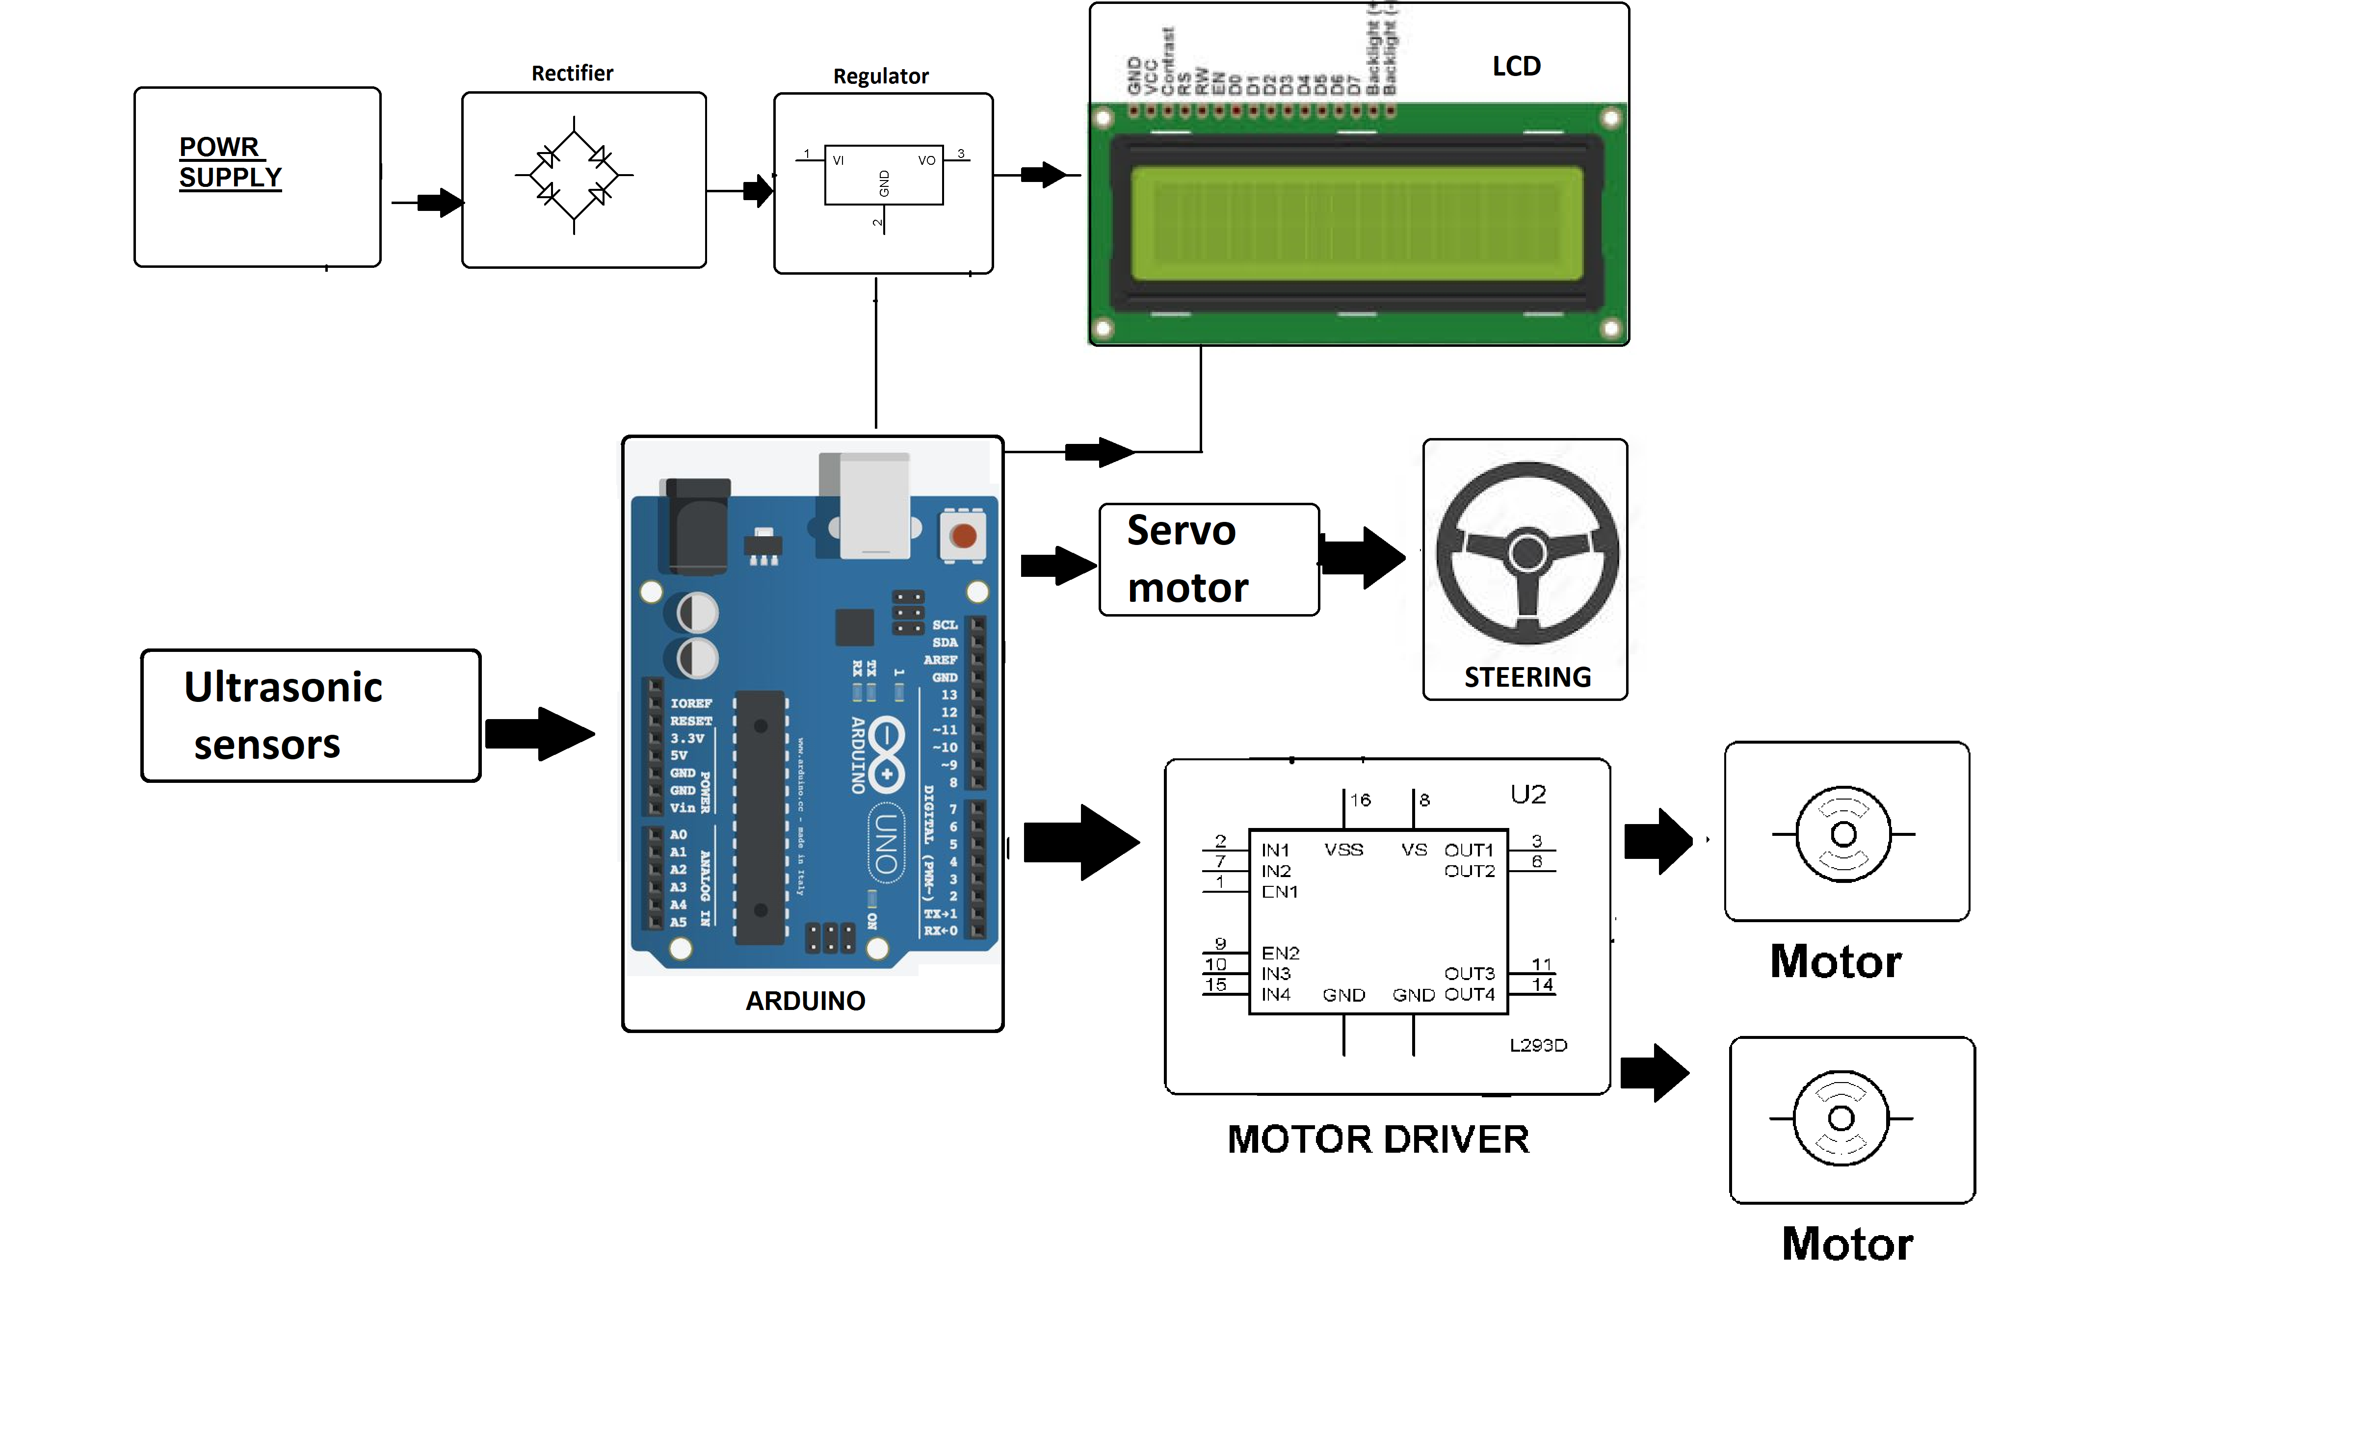

Hardware Specifications

- Arduino Uno
- Ultrasonic Sensor
- Servo Motor
- LCD Display
- Resistors
- Capacitors
- Transistors
- Cables and Connectors
- Diodes
- PCB and Breadboards
- LED
- Transformer/Adapter
- Push Buttons
- Switch
- IC
- IC Sockets

Software Specifications

- Arduino Compiler
- Programming Language: C

